# Panaudojimo atvejų diagrama

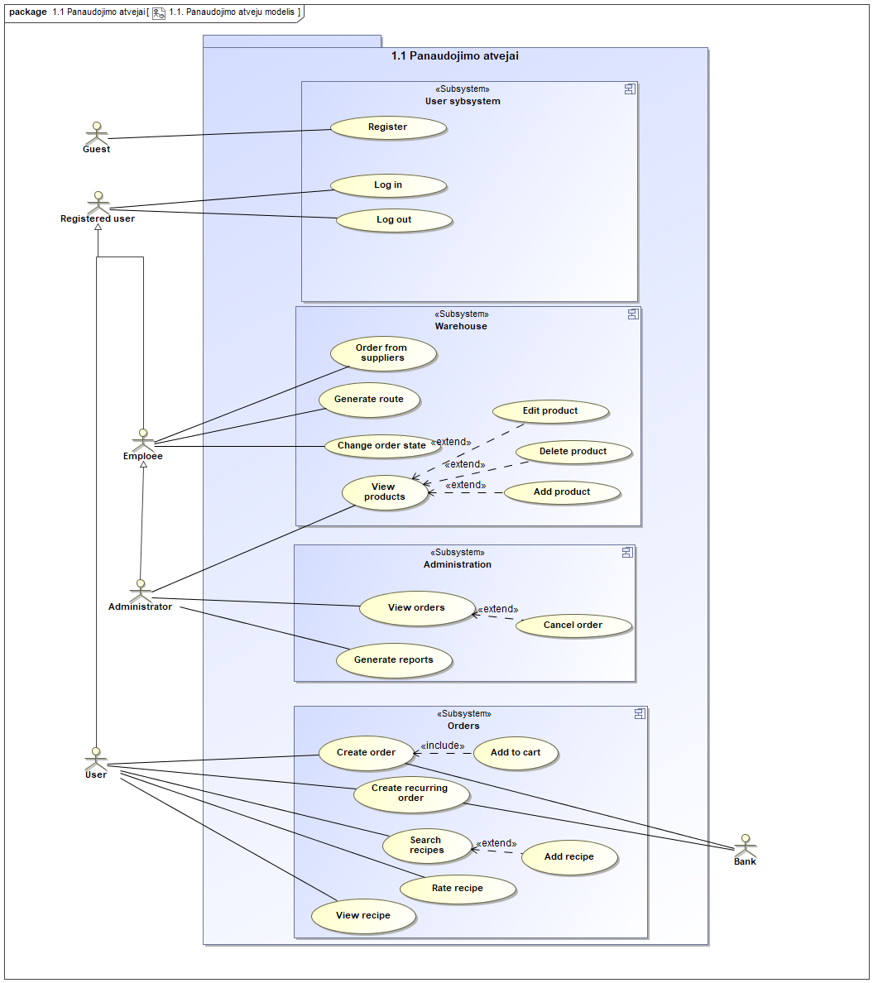

“1.1. Panaudojimo atveju modelis” panaudojimo atvejų diagrama

|  |  |  |  |
| --- | --- | --- | --- |
| **Panaudojimo atvejis** | | “Log out” |  |
| **Tikslas.** | | | |
| **Aprašymas.** | | | |
| **Prieš sąlyga** | |  | |
| **Aktoriai** | | Registered user | |
| **Susiję panaudojimo atvejai** | **Apimami PA** |  | |
| **Išplečiantys PA** |  | |
| **Specializuojami PA** |  | |
| **Po sąlyga** | |  | |

|  |  |  |  |
| --- | --- | --- | --- |
| **Panaudojimo atvejis** | | “Create order” | Evaldas |
| **Tikslas.**  Order created | | | |
| **Aprašymas.** | | | |
| **Prieš sąlyga** | | User should be logged in | |
| **Aktoriai** | | Bank  User | |
| **Susiję panaudojimo atvejai** | **Apimami PA** |  | |
| **Išplečiantys PA** |  | |
| **Specializuojami PA** |  | |
| **Po sąlyga** | | Recipes should be in shopping cart | |

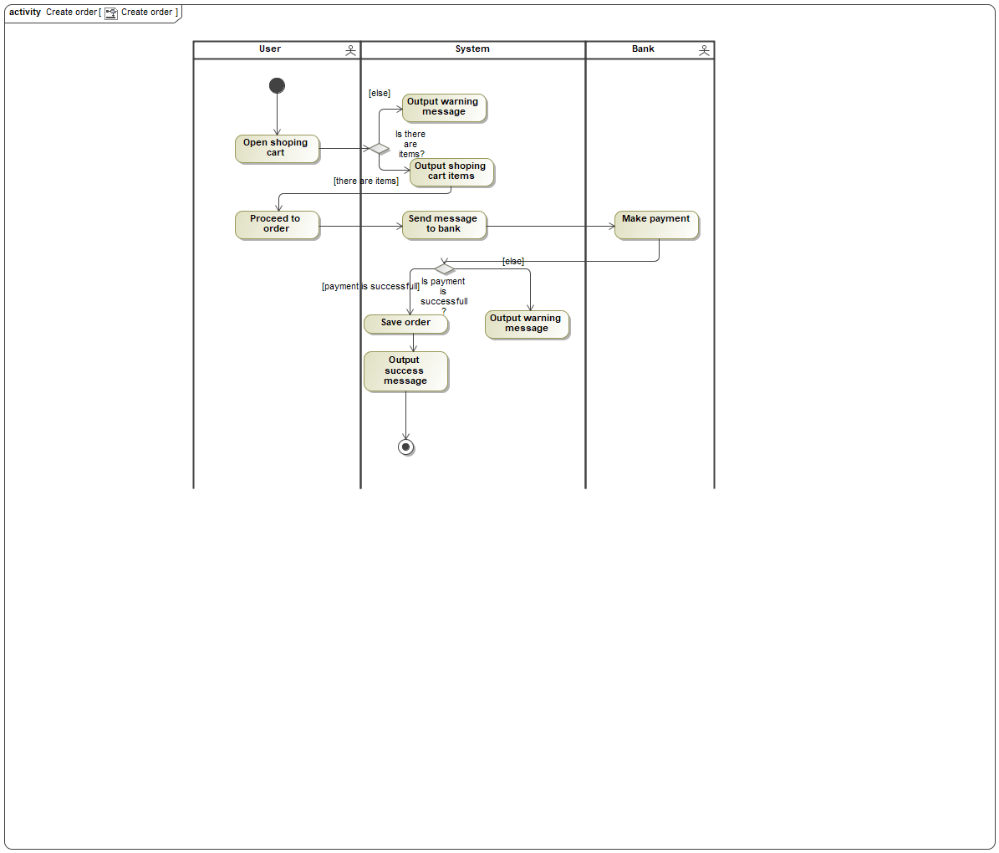

Panaudojimo atvejo “Create order” scenarijus

|  |  |  |  |
| --- | --- | --- | --- |
| **Panaudojimo atvejis** | | “Create recurring order” | Evaldas |
| **Tikslas.**  can create recurring order | | | |
| **Aprašymas.** | | | |
| **Prieš sąlyga** | | User must be logged in | |
| **Aktoriai** | | Bank  User | |
| **Susiję panaudojimo atvejai** | **Apimami PA** |  | |
| **Išplečiantys PA** |  | |
| **Specializuojami PA** |  | |
| **Po sąlyga** | | Orders should be made before | |

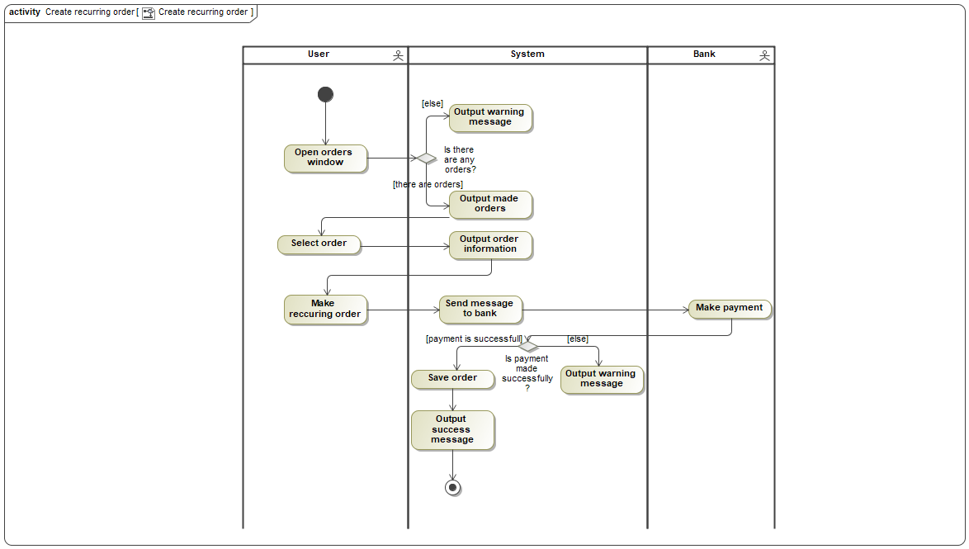

Panaudojimo atvejo “Create recurring order” scenarijus

|  |  |  |  |
| --- | --- | --- | --- |
| **Panaudojimo atvejis** | | “Add to cart” | Evaldas |
| **Tikslas.**  User can add items to cart | | | |
| **Aprašymas.** | | | |
| **Prieš sąlyga** | | User must be logged in | |
| **Aktoriai** | |  | |
| **Susiję panaudojimo atvejai** | **Apimami PA** | “Create order” | |
| **Išplečiantys PA** |  | |
| **Specializuojami PA** |  | |
| **Po sąlyga** | | Recipe should be chosen | |

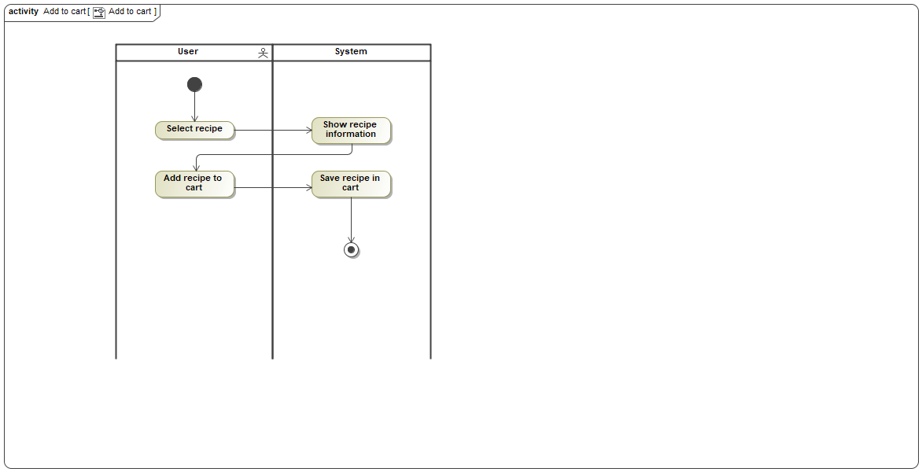

Panaudojimo atvejo “Add to cart” scenarijus

|  |  |  |  |
| --- | --- | --- | --- |
| **Panaudojimo atvejis** | | “Edit product” | Nerijus |
| **Tikslas.**  Product can be edited | | | |
| **Aprašymas.** Product details can be changed | | | |
| **Prieš sąlyga** | | User must be logged in as an admin | |
| **Aktoriai** | |  | |
| **Susiję panaudojimo atvejai** | **Apimami PA** |  | |
| **Išplečiantys PA** |  | |
| **Specializuojami PA** |  | |
| **Po sąlyga** | | Product details are updated | |

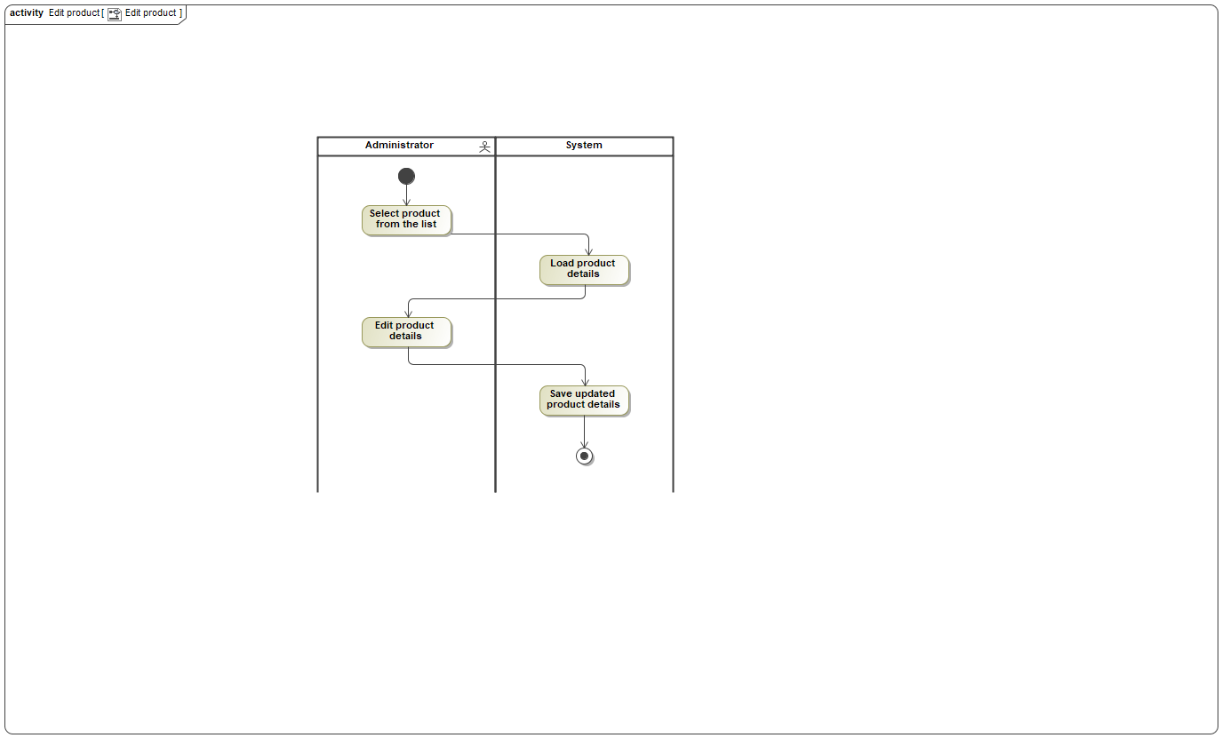

Panaudojimo atvejo “Edit product” scenarijus

|  |  |  |  |
| --- | --- | --- | --- |
| **Panaudojimo atvejis** | | “Generate route” | Nerijus |
| **Tikslas.**  Should generate new optimal route to deliver multiple orders | | | |
| **Aprašymas.** Should generate new optimal route to deliver multiple orders | | | |
| **Prieš sąlyga** | | User must be logged in as an admin and not closed order list should contain at least 1 order | |
| **Aktoriai** | | Emploee | |
| **Susiję panaudojimo atvejai** | **Apimami PA** |  | |
| **Išplečiantys PA** |  | |
| **Specializuojami PA** |  | |
| **Po sąlyga** | | New route is generated | |

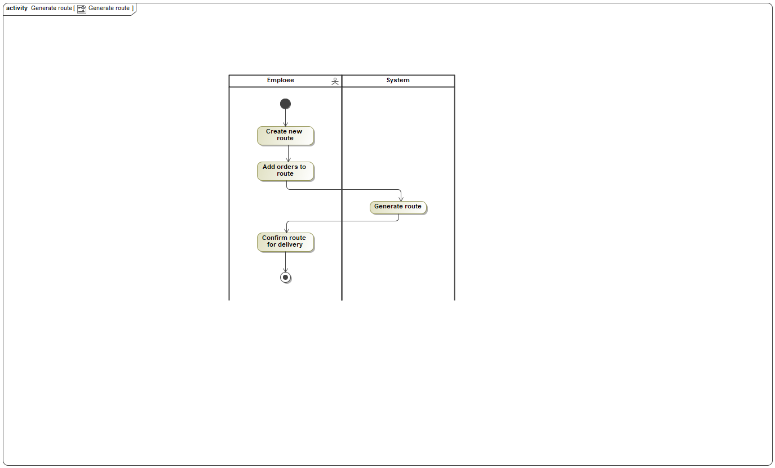

Panaudojimo atvejo “Generate route” scenarijus

|  |  |  |  |
| --- | --- | --- | --- |
| **Panaudojimo atvejis** | | “View orders” | Arunas |
| **Tikslas.**  Allow the administrator to manage orders | | | |
| **Aprašymas.** | | | |
| **Prieš sąlyga** | | User must be logged in as administrator | |
| **Aktoriai** | | Administrator | |
| **Susiję panaudojimo atvejai** | **Apimami PA** |  | |
| **Išplečiantys PA** | “Cancel order” | |
| **Specializuojami PA** |  | |
| **Po sąlyga** | | List of users orders should be shown | |

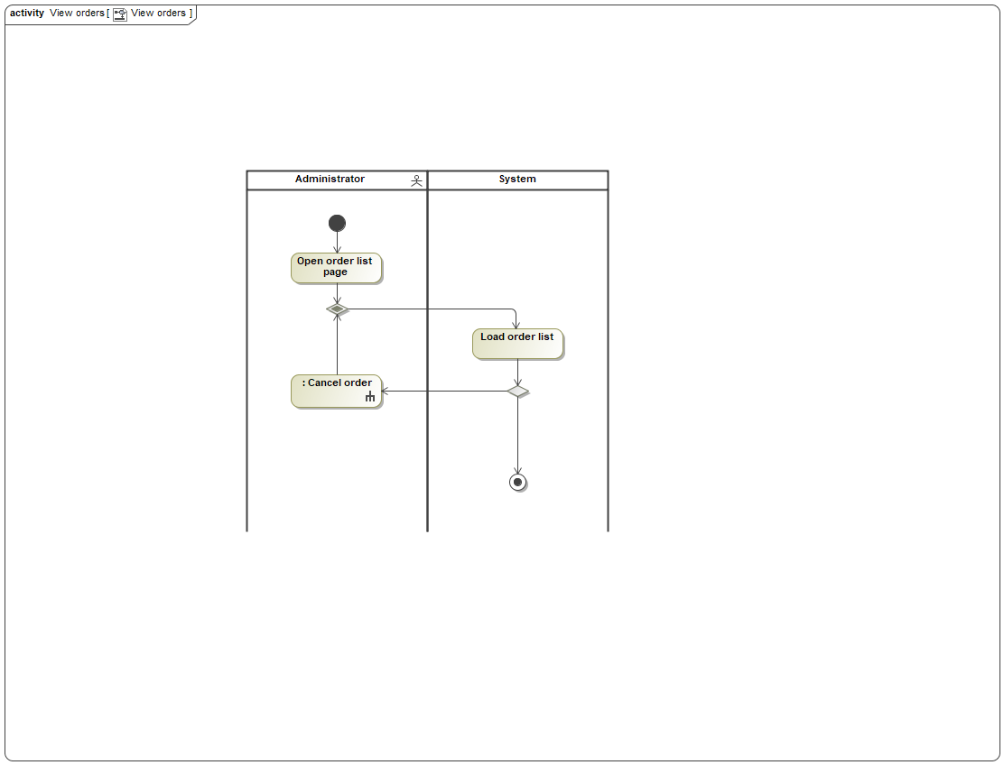

Panaudojimo atvejo “View orders” scenarijus

|  |  |  |  |
| --- | --- | --- | --- |
| **Panaudojimo atvejis** | | “Add recipe” | Evaldas |
| **Tikslas.**  Can add new recipe | | | |
| **Aprašymas.** | | | |
| **Prieš sąlyga** | | User must be logged in | |
| **Aktoriai** | |  | |
| **Susiję panaudojimo atvejai** | **Apimami PA** |  | |
| **Išplečiantys PA** |  | |
| **Specializuojami PA** |  | |
| **Po sąlyga** | | Should chose to add new recipe | |

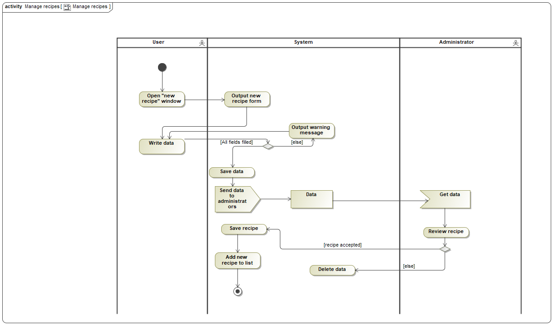

Panaudojimo atvejo “Manage recipes” scenarijus

|  |  |  |  |
| --- | --- | --- | --- |
| **Panaudojimo atvejis** | | “Log in” |  |
| **Tikslas.** | | | |
| **Aprašymas.** | | | |
| **Prieš sąlyga** | |  | |
| **Aktoriai** | | Registered user | |
| **Susiję panaudojimo atvejai** | **Apimami PA** |  | |
| **Išplečiantys PA** |  | |
| **Specializuojami PA** |  | |
| **Po sąlyga** | |  | |

|  |  |  |  |
| --- | --- | --- | --- |
| **Panaudojimo atvejis** | | “View products” | Nerijus |
| **Tikslas.**  Allow to view prodict list | | | |
| **Aprašymas.** Allows an admin to add, edit and delete products | | | |
| **Prieš sąlyga** | | User must be logged in as an admin | |
| **Aktoriai** | | Administrator | |
| **Susiję panaudojimo atvejai** | **Apimami PA** |  | |
| **Išplečiantys PA** | “Add product”  “Delete product”  “Edit product” | |
| **Specializuojami PA** |  | |
| **Po sąlyga** | | Product list must be shown | |

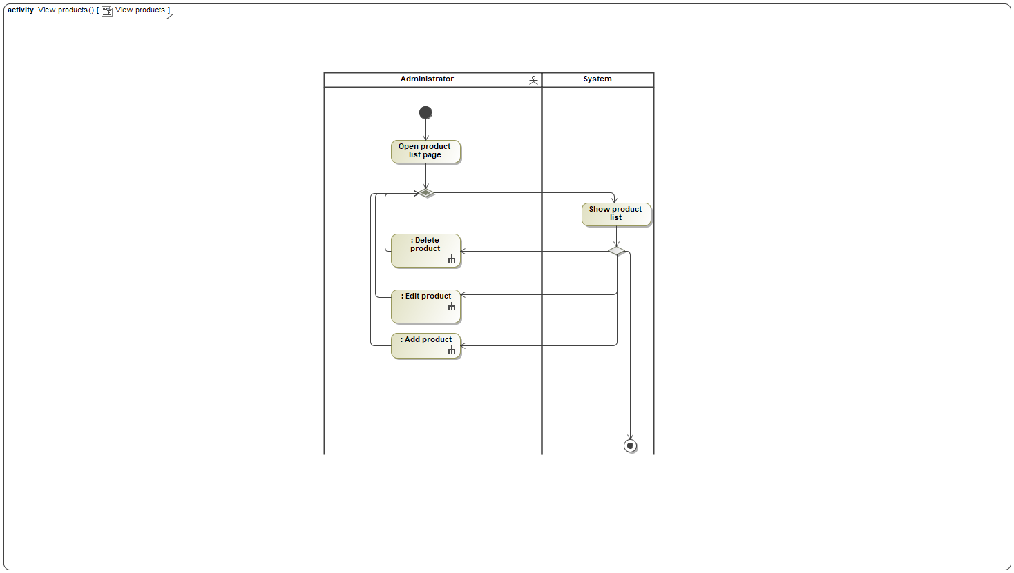

Panaudojimo atvejo “View products” scenarijus

|  |  |  |  |
| --- | --- | --- | --- |
| **Panaudojimo atvejis** | | “Order from suppliers” | Nerijus |
| **Tikslas.**  Allow to order products to warehouse | | | |
| **Aprašymas.** Allows an admin to order needed product from suppliers to warehous | | | |
| **Prieš sąlyga** | | User must be logged in as an admin | |
| **Aktoriai** | | Emploee | |
| **Susiję panaudojimo atvejai** | **Apimami PA** |  | |
| **Išplečiantys PA** |  | |
| **Specializuojami PA** |  | |
| **Po sąlyga** | | New order should be placed for supplier | |

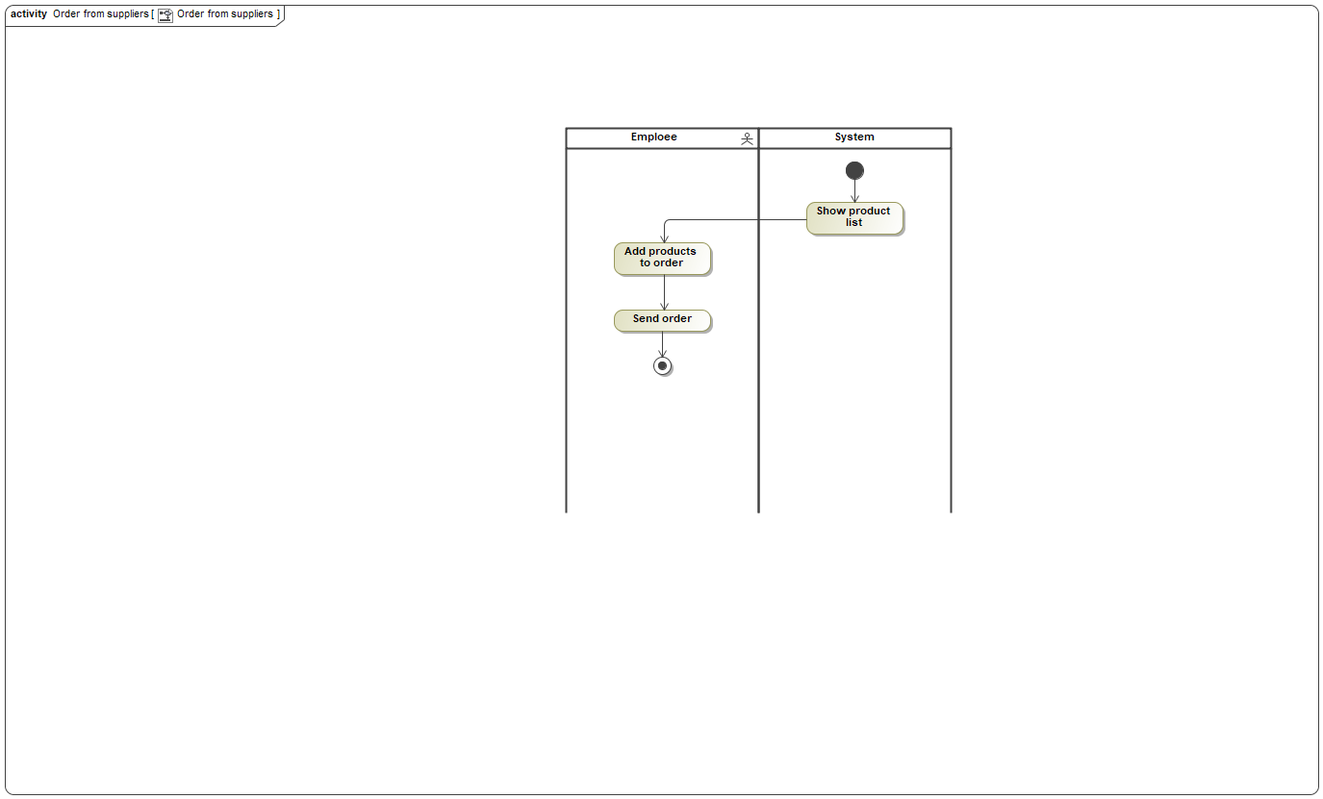

Panaudojimo atvejo “Order from suppliers” scenarijus

|  |  |  |  |
| --- | --- | --- | --- |
| **Panaudojimo atvejis** | | “Delete product” |  |
| **Tikslas.**  Product is deleted from the list | | | |
| **Aprašymas.** Product can be deleted from all products list | | | |
| **Prieš sąlyga** | | User must be logged in as an admin | |
| **Aktoriai** | |  | |
| **Susiję panaudojimo atvejai** | **Apimami PA** |  | |
| **Išplečiantys PA** |  | |
| **Specializuojami PA** |  | |
| **Po sąlyga** | | Product is deleted from the list | |

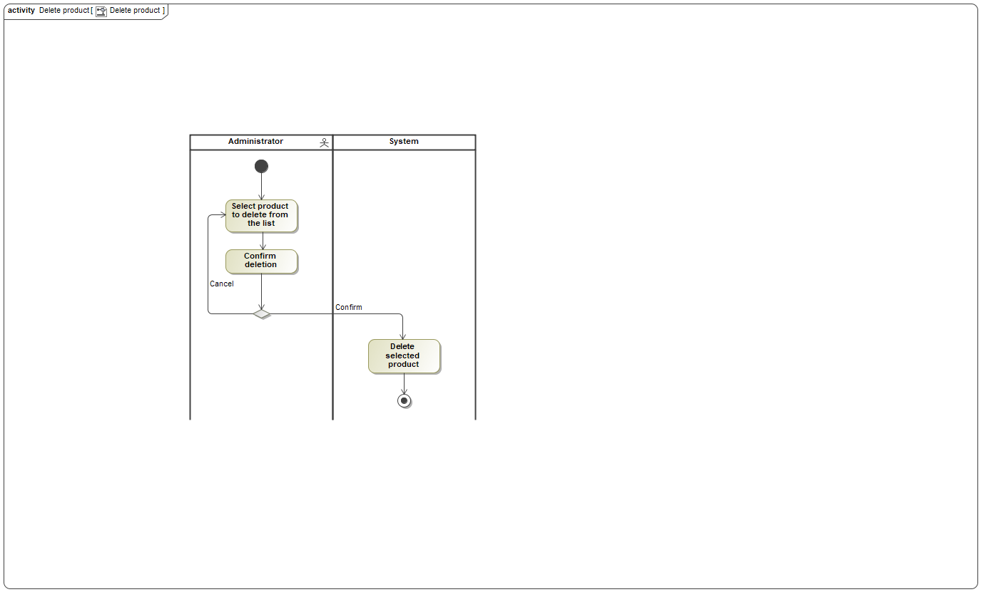

Panaudojimo atvejo “Delete product” scenarijus

|  |  |  |  |
| --- | --- | --- | --- |
| **Panaudojimo atvejis** | | “Change order state” | Nerijus |
| **Tikslas.**  Employee can change order state | | | |
| **Aprašymas.** Employee can change order state | | | |
| **Prieš sąlyga** | | User must be logged in as an employee and not closed order list should have orders | |
| **Aktoriai** | | Emploee | |
| **Susiję panaudojimo atvejai** | **Apimami PA** |  | |
| **Išplečiantys PA** |  | |
| **Specializuojami PA** |  | |
| **Po sąlyga** | | Order state is changed | |

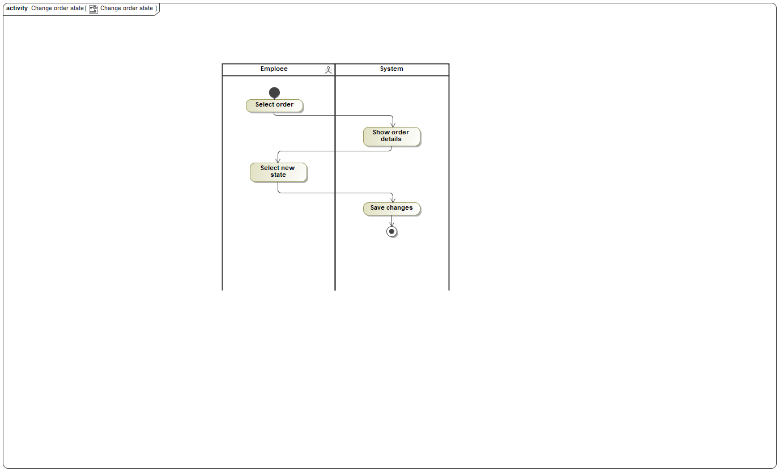

Panaudojimo atvejo “Change order state” scenarijus

|  |  |  |  |
| --- | --- | --- | --- |
| **Panaudojimo atvejis** | | “Rate recipe” | Arunas |
| **Tikslas.**  To allow user to find the best recipes | | | |
| **Aprašymas.** | | | |
| **Prieš sąlyga** | | User is logged in | |
| **Aktoriai** | | User | |
| **Susiję panaudojimo atvejai** | **Apimami PA** |  | |
| **Išplečiantys PA** |  | |
| **Specializuojami PA** |  | |
| **Po sąlyga** | | Recipe rating is updated | |

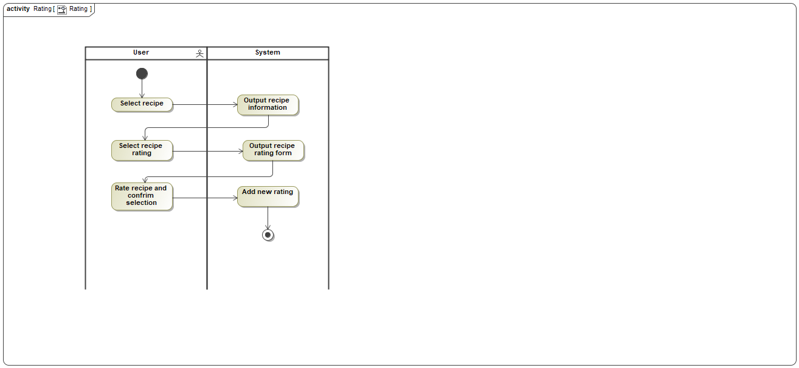

Panaudojimo atvejo “Rating” scenarijus

|  |  |  |  |
| --- | --- | --- | --- |
| **Panaudojimo atvejis** | | “Generate reports” | Arūnas |
| **Tikslas.**  Generate a report | | | |
| **Aprašymas.** User should be able to generate different reports for specified date ranges. | | | |
| **Prieš sąlyga** | | User must be logged in as an admin | |
| **Aktoriai** | | Administrator | |
| **Susiję panaudojimo atvejai** | **Apimami PA** |  | |
| **Išplečiantys PA** |  | |
| **Specializuojami PA** |  | |
| **Po sąlyga** | | Report should be generated for specified date range | |

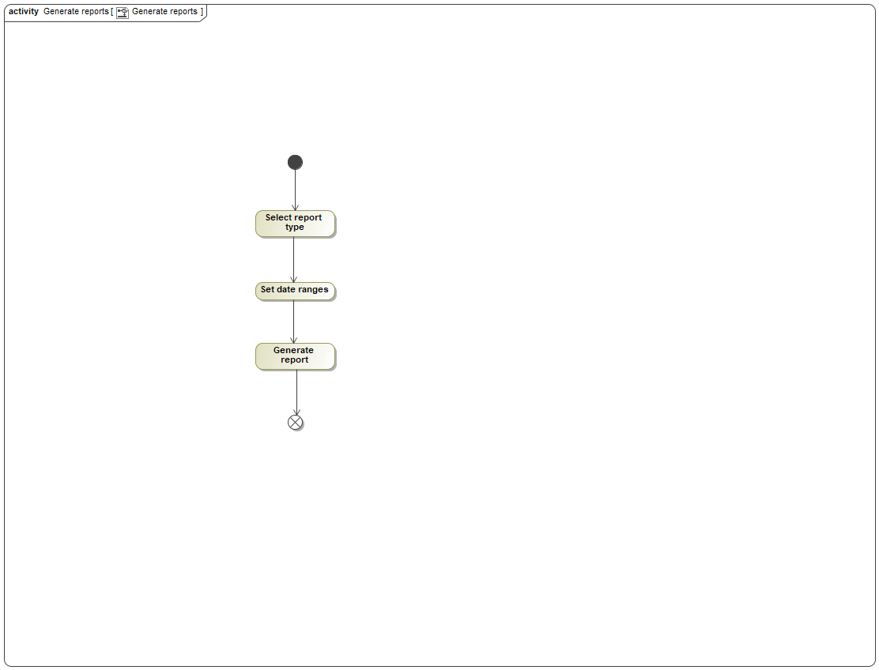

Panaudojimo atvejo “Generate reports” scenarijus

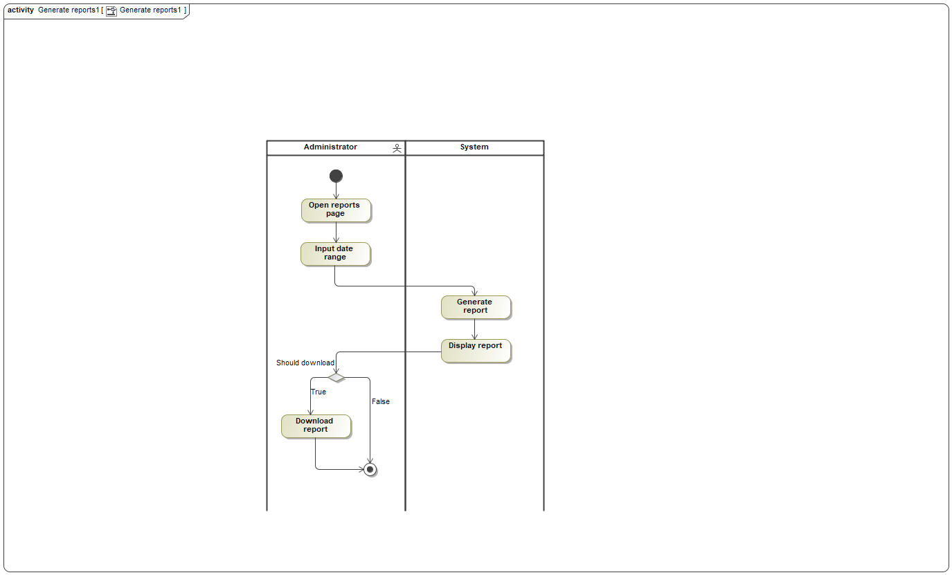

Panaudojimo atvejo “Generate reports1” scenarijus

|  |  |  |  |
| --- | --- | --- | --- |
| **Panaudojimo atvejis** | | “Register” |  |
| **Tikslas.** | | | |
| **Aprašymas.** | | | |
| **Prieš sąlyga** | |  | |
| **Aktoriai** | | Guest | |
| **Susiję panaudojimo atvejai** | **Apimami PA** |  | |
| **Išplečiantys PA** |  | |
| **Specializuojami PA** |  | |
| **Po sąlyga** | |  | |

|  |  |  |  |
| --- | --- | --- | --- |
| **Panaudojimo atvejis** | | “View recipe” | Evaldas |
| **Tikslas.**  User can view recipes | | | |
| **Aprašymas.** | | | |
| **Prieš sąlyga** | | User must be logged in | |
| **Aktoriai** | | User | |
| **Susiję panaudojimo atvejai** | **Apimami PA** |  | |
| **Išplečiantys PA** |  | |
| **Specializuojami PA** |  | |
| **Po sąlyga** | | Recipes are found | |

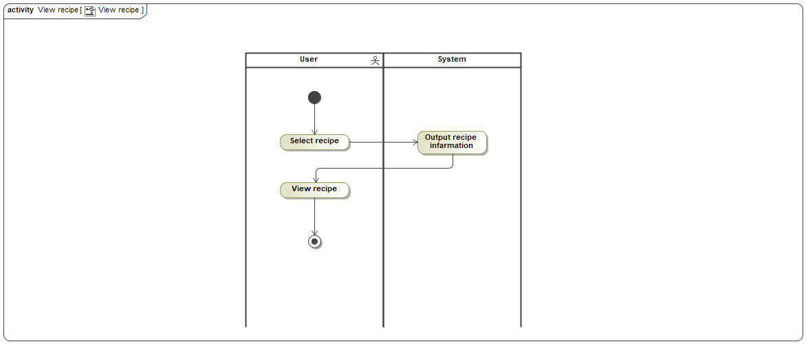

Panaudojimo atvejo “View recipe” scenarijus

|  |  |  |  |
| --- | --- | --- | --- |
| **Panaudojimo atvejis** | | “Add product” | Nerijus |
| **Tikslas.**  New product is added | | | |
| **Aprašymas.** New product can be added | | | |
| **Prieš sąlyga** | | User must be logged in as an admin | |
| **Aktoriai** | |  | |
| **Susiję panaudojimo atvejai** | **Apimami PA** |  | |
| **Išplečiantys PA** |  | |
| **Specializuojami PA** |  | |
| **Po sąlyga** | | New product is added to all products list | |

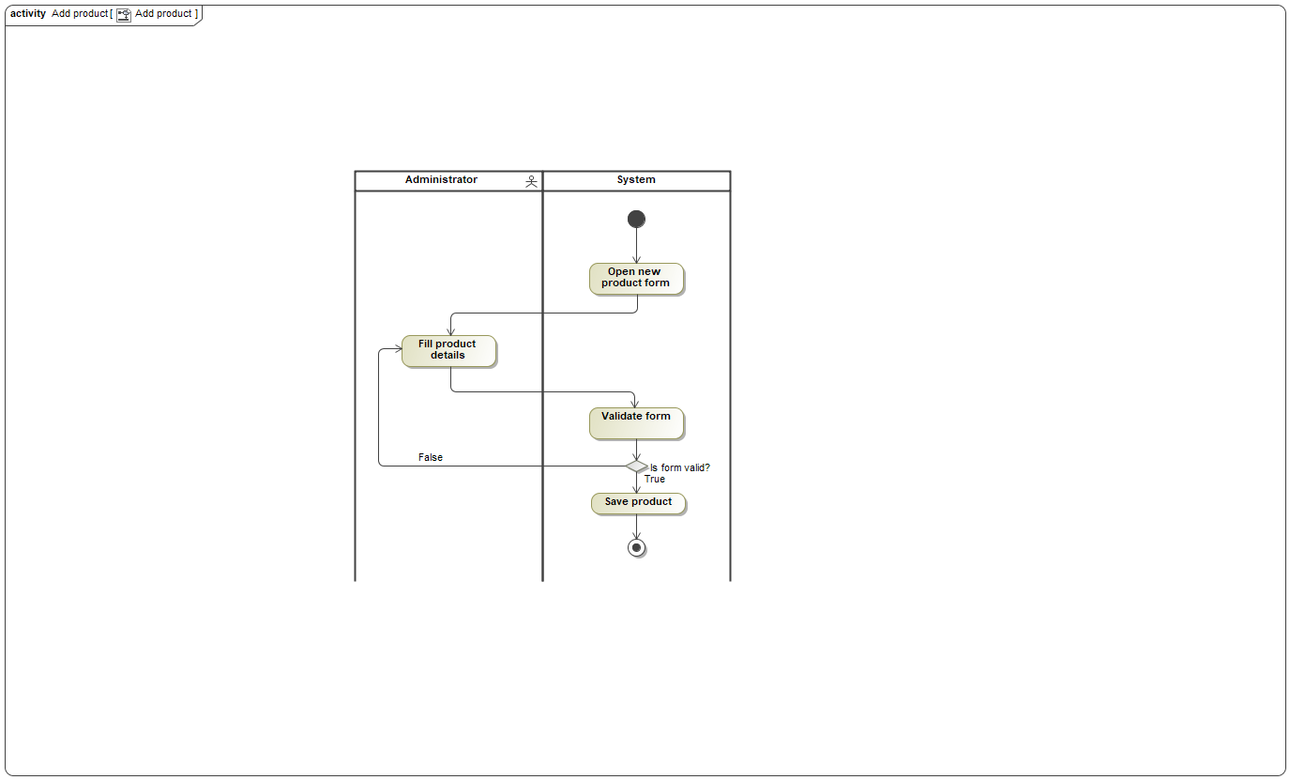

Panaudojimo atvejo “Add product” scenarijus

|  |  |  |  |
| --- | --- | --- | --- |
| **Panaudojimo atvejis** | | “Search recipes” | Evaldas |
| **Tikslas.**  User can find recipes | | | |
| **Aprašymas.** | | | |
| **Prieš sąlyga** | | User must be logged in | |
| **Aktoriai** | | User | |
| **Susiję panaudojimo atvejai** | **Apimami PA** |  | |
| **Išplečiantys PA** | “Add recipe” | |
| **Specializuojami PA** |  | |
| **Po sąlyga** | | Recipe should be chosen | |

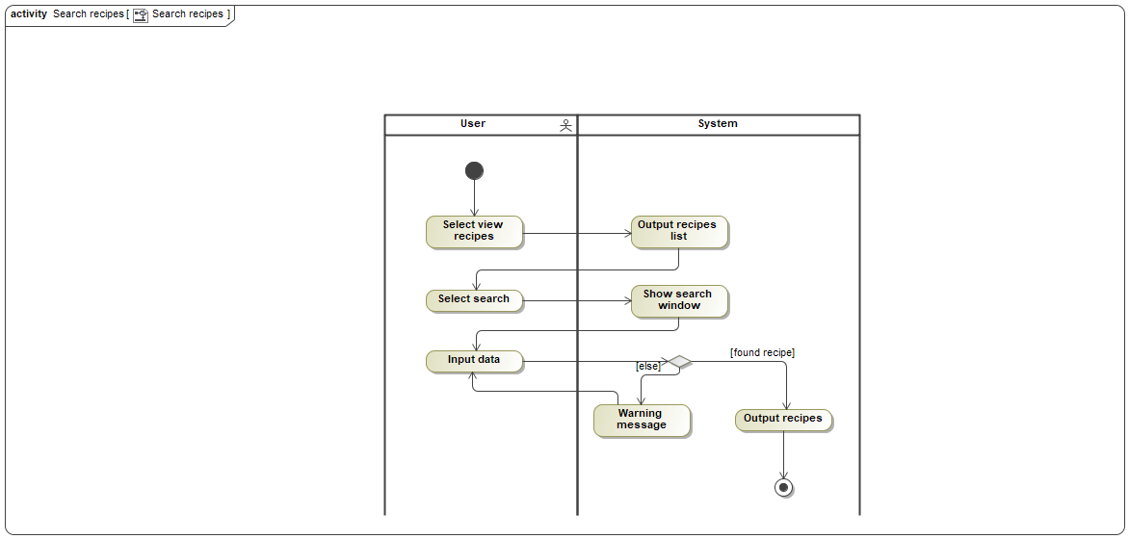

Panaudojimo atvejo “Search recipes” scenarijus

|  |  |  |  |
| --- | --- | --- | --- |
| **Panaudojimo atvejis** | | “Cancel order” | Arunas |
| **Tikslas.**  Order is canceled | | | |
| **Aprašymas.** Users order can be canceled by an admin | | | |
| **Prieš sąlyga** | | User must be logged in as an admin | |
| **Aktoriai** | |  | |
| **Susiję panaudojimo atvejai** | **Apimami PA** |  | |
| **Išplečiantys PA** |  | |
| **Specializuojami PA** |  | |
| **Po sąlyga** | | Client can see that his order was canceled by an adm in | |

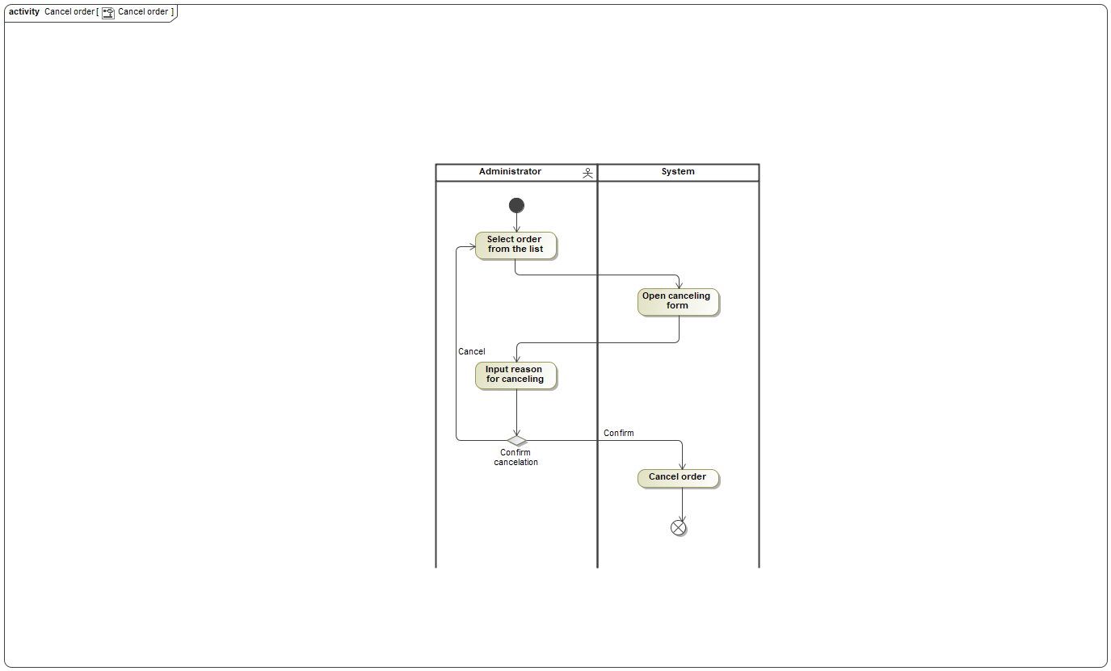

Panaudojimo atvejo “Cancel order” scenarijus